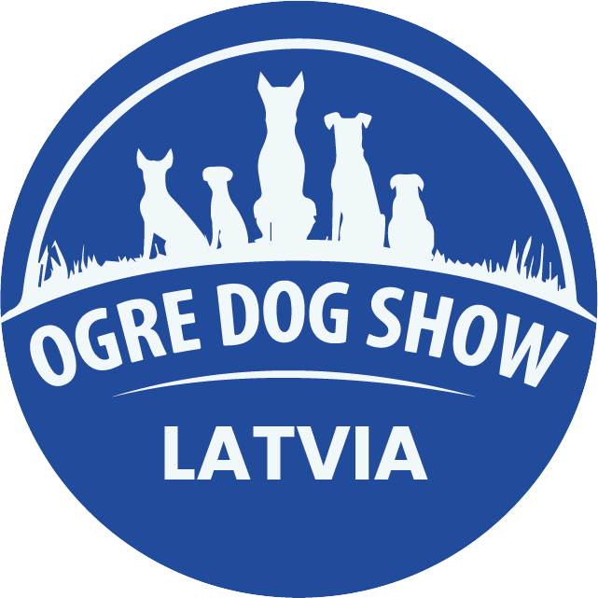
OGRE KENNEL CLUB
National Dog Shows
OGRE DOG SHOW 2026
July 18 and 19, 2026

LETTER OF GUARANTEE
I, ____________________________________________________________________________ (name, surname),
Address: _______________________________________________________________________________________,
Phone: _______________________________ E-mail: ______________________________________________,
hereby guarantee, under any circumstances, to fully or partially pay the entry fee for my dog(s) registered for the Ogre Kennel Club National Dog Show OGRE DOG SHOW 2026, which will take place on July 18 and 19, 2026.
Guaranteed amount: EUR ________ (____________________________________________________)
I guarantee payment also in the event that I or my dog does not attend the show.
Payment shall be made within 7 (seven) days after the show, no later than July 26, 2026.

Dogs for which payment is guaranteed
No. | 18.07 | 19.07 | Breed | Dog’s Name | Pedigree No. | Owner’s Name, Surname | EUR

Total: € __________________
Date: __________________________
Signature: __________________________ Name, Surname: ______________________________________________

Bank Details
Association Ogre Kennel Club
Registration No. 40008015625
AS Swedbank
SWIFT: HABALV22
Account No.: LV22HABA0551035049310

